|  |  |
| --- | --- |
| **Year 11 Essentials** Mini Test 1.3Rates, Perimeter and AreaResources allowed: Calculator and 1 x A4 page one side Name:________________ | |
| Show all working out for full marks | Total: /20 |

1. What unit of measurement would you use to measure the following things [3]
2. Flow rate of a hose?
3. Speed of a bird flying?
4. Swimming speed of a human?
5. If you have a 2.5m piece of wood, and you needed 6 pieces cut, **estimate** how long should each piece be?(nearest 10cm) [2]
6. If a room is 6.2 metres long, and 4.8 meters wide, **estimate** how big is the room is to the nearest square meter? *(hint- draw a diagram and don’t give exact answer)* [3]
7. Find the perimeter of the following shapes [2]

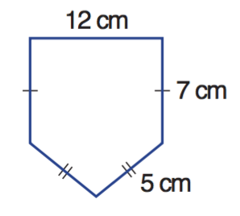

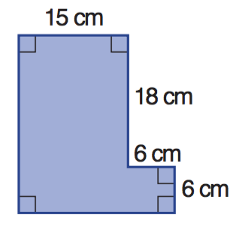a b

P =____________________ P =____________________

1. Use the following table to convert these imperial units to SAE [8]

|  |  |
| --- | --- |
| **IMPERIAL** | **METRIC** |
| 1 inch | 2.54cm |
| 1 foot | 30.4cm |
| 1 yard | 91.44cm |
| 1 mile | 1.609km |

1. 30 feet to meters
2. 40 inches to centimetres
3. 65 metres to yards
4. 60 miles to Kilometres
5. If 1 square foot is equal to 0.093m2, how big is a 2500 square foot house in m2 ? [2]